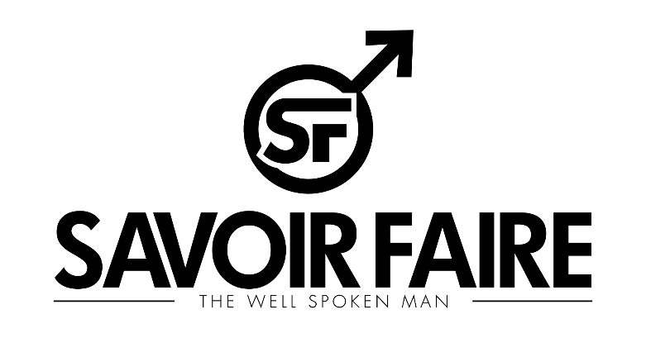
PHOTOGRAPHY RELEASE
_________________________________________
By filling out this digital release form, I (Name Listed Below) hereby grant Savoir Faire Magazine permission to use the photography or other content submitted in their publication, including their website & internet postings. I verify that I have the right to publish the people in the pictures and that I own the rights to have these pictures (or other content) distributed, published, or otherwise promoted by Savoir Faire Magazine as they see fit for their publication. I certify that this work of art is not plagiarized from another source.
I understand that the picture(s) (or other content) I submit to Savoir Faire Magazine may be used in their publication in print or digitally as well as on their website and other social media and internet postings.
I understand that by completing this form only allows Savoir Faire Magazine to use my photos (or other content) in their publication, and at no time will Savoir Faire Magazine assume rights to the photos (or other content) themselves, other than me allowing them the right to publish the photos (or other content submitted and should they then post pages from the publication on their website or in internet postings.
I understand that at no time shall I be paid, reimbursed, compensated, given a free magazine, or given royalties, now or at any point in the future by Savoir Faire Magazine.
I hereby irrevocably authorize Savoir Faire Magazine to copy, exhibit, publish or distribute these photos (or other content) in their publication for purposes of publicizing Savoir Faire Magazine in their publication, website or internet postings or for any other lawful purpose. I am also giving the right for Savoir Faire Magazine to make any necessary edits (i.e. crop/resize ...) to fit the publication.
I hereby hold harmless and release and forever discharge Savoir Faire Magazine from all claims, demands, and causes of action which I, my heirs, representatives, executors, administrators, or any other persons acting on my behalf or on the behalf of my estate have or may have by reason of this authorization.
I certify that the person or ALL person(s) in the photo(s) are at least 18 years of age. If they are under the age of 18, I certify that their parent or legal guardian has given approval. I have read this release and I fully understand the contents, meaning, and impact of this release.
I affirm that all given statements to the magazine are true. As the provider, I also understand that submissions of content, or completion of release, is not a guarantee of publication. If Work is published, it is the duty of the provider (and not Savoir Faire Magazine) to notify all involved parties of their involvement in the final product.

______________________________________
Print Name:

______________________________________
Signed Name:

______________________________________
Date:

